Async, Promises, Callbacks, Databases, Data Modeling, & SQL
Working with your Trio/Buddy:
- Discuss: What's a hobby you've picked up recently or would like to try?
- Reflection: How has working in groups each week changed your approach to learning new technical concepts?
- Explore: What do you know about using the following SQL keywords: Where, Desc, Asc, Order By? Are there differences between promises and callbacks?

⚠️NOTE: This milestone is another meaty one. Please try to only skim each topic, you will be getting much more practice with databases over the next several milestones. Prioritize your time this milestone – NO RABBIT HOLES!!!

Async, Callbacks, & Promises
Techtonica promises lesson. You will pretty much never have to create a promise from scratch as a software developer. But, it’s a good topic outline to help you solidify the concept of “Promises”.
JavaScript is an event-driven language. Instead of waiting for things to happen, it executes while listening for events. The way you respond to an event is by using callbacks. There are best practices for error messages and how to use those callbacks functions when you’re creating your own API.

Resources
- 🌐How to Use JavaScript Promises – Callbacks, Async/Await, and Promise Methods Explained
- 📰What they didn’t tell you about JS Promise
- 🎦Promises with volunteer Roberto Rodriguez

Intro to Databases
This milestone is all about understanding and using databases - focus on how to model your data this milestone. This is the information that you won’t be able to find on google because modeling your data is personal work (or a group if you’re working in a team). Do not skip understanding the process of how to data model, as it is the first step in the process of using a database. You need to understand what you’re doing when you are thinking about your data and how to think about your data, in addition to the question: from where is coming to my data (API connection). Also, note that some people make their entire careers planning out databases, we don’t expect you to be experts overnight!

Data Modeling with SQL: Single Tables
Data modeling refers to how you organize the data within your database, and is the first step to creating a database. Having incorrect data models can cause your application to have inconsistent or inaccurate data, so it's important to come up with data models that will represent your data well.

SQL
SQL is a database computer language designed for the retrieval and management of data in a relational database. SQL stands for Structured Query Language. RDBMS stands for Relational Database Management System. A Relational database management system (RDBMS) is a database management system (DBMS) that is based on the relational model as introduced by E. F. Codd. RDBMS is the basis for SQL, and for all modern database systems like MS SQL Server, IBM DB2, Oracle, MySQL, and Microsoft Access.

Specific Things to Learn - Get started with learning about SQL Single Table Operations
- Create a table
- Query data from a table
- Filter and limit
- Insert data into a table
- Update
- Delete

Resources
- 🎦Discussing Database Table Connections with Volunteer Cristina Rodriguez
- 🎦PostgreSQL: Study Group 1 & Study Group 2

Pair Programming - Create routes with Express
Use whatever tutorials you want to help you make your server with a couple routes, this is a good one

Resources
- 🌐Learn Express
- 🎦Initializing Express & Beginning Routes with Volunteer Cristina Rodriguez
- 🎦Using Fetch to Access APIs with Volunteer Cristina Rodriguez

Milestone Project - RESTful API Instructions - Connect to a static array of data
- Step 1: Build a rest api to show me groups of data in a static array. For example, this is a static array to hold your books (think an array of objects). It's okay if you would like to use data that is different from the books example. Do not make a database for your data yet - yet (you will build a database later in the milestone).
- Step 2: Define the endpoints to interact with the books' data. Take your time thinking through this process.
  - Using Node and Express, create a GET router with a response that converts all using JSON.
  - Using that endpoint, build a list of all your “books” in the backend (server side).
  - Using Node and Express, create a route for each one of the verbs in CRUD operations in the backend. You don't need to have a frontend to do this; you can test your API using Postman or cURL!
- Bonus: Using that endpoint, build a list of all your books in the frontend (client side). Note: you will need to make a GET request to bring all your information to the client too.
- Commit after every working change, 50+ commits
- Share at least 1 PR

Open Source Activity
This milestone you will get acclimated with open source projects. By the end of the milestone, you will need to become a ✨contributor✨on an open source project. This process can take some time between finding your project (list of where to start), reading onboarding documentation, setting up the project locally, and getting approved as a contributor. Give yourself at least three to four days for the last two steps (setting up and being approved). During your project share, you will also show how far you have come in the process of becoming a contributor and what you learned in doing so.

Start reading through your open source project documentation, today.

💡Can you describe what is occurring in this photo in terms of Full-Stack Architecture?
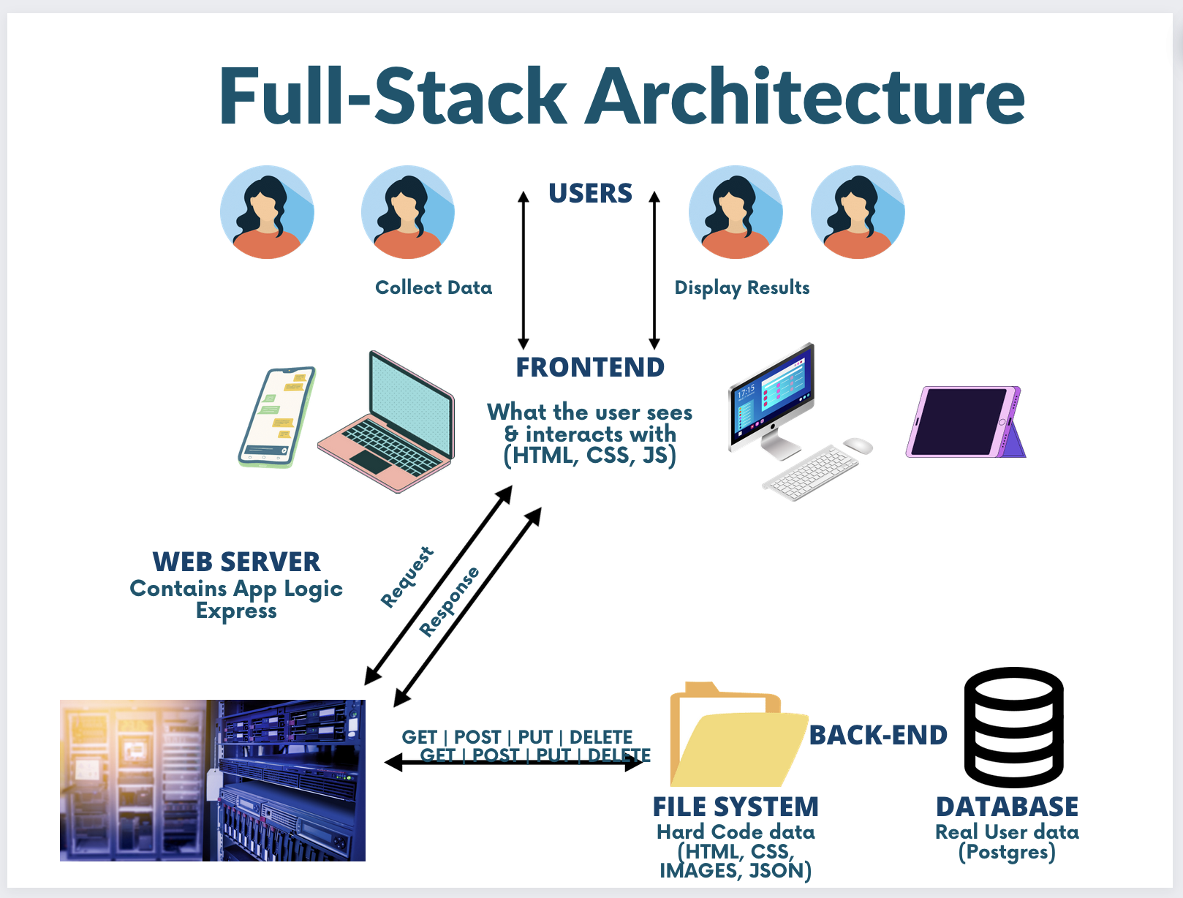

Objective Skills You Should Have at the End of the Day:
- How to model your data in the database
- How to set up and use a database
- How to query data from a database
- How to connect a database to Node/Express to make an app that can store data

End-of-day Questions:

Promises & Callbacks:
- What is a callback function?
- Why do we use callbacks?
- How many things can be returned from a callback?
- How do I get data out of a callback?
- Define a promise in your own words.

Data Modeling:
- What is a table?
- What is an Entity?
- What is an Attribute?
- What are the Data types in a DB?
- What is a Primary key?
- What is a Schema?
- Given a scenario where a bookstore wants to keep track of books and authors, how would you model this data in a database? Can you describe the possible columns and relationships between the tables?
Database:
- Describe the steps you would take to connect a database to a Node / Express application.
- Why is this connection important?
- How to model your data in the database
- How to set up and use a database
- How to query data from a database
- How to connect a database to Node/Express to make an app that can store data

SQL Basics & Querying Data:
- What does SQL stand for, and what is its primary purpose in the context of a Relational Database Management System (RDBMS)?
- A table named "Students" has columns: "StudentID", "FirstName", "LastName", and "Grade". Write an SQL query to retrieve the first names of students who have a grade of 'A'.
- Imagine you have a table named "Products" and you've just been informed that the price of the product with ProductID '123' needs to be updated to '$50'. Write the SQL command to accomplish this.

QUIZ EOD: Callbacks & Promises

